For Immediate Release
Contact: Shannon Egan, Director, The Trout Gallery
717-245-1709; egansh@dickinson.edu

Exhibition of Art and Sound at The Trout Gallery: To Listen Deeply

Carlisle, PA – The Trout Gallery is pleased to present an exhibition titled To Listen Deeply on display through December 14, 2025.
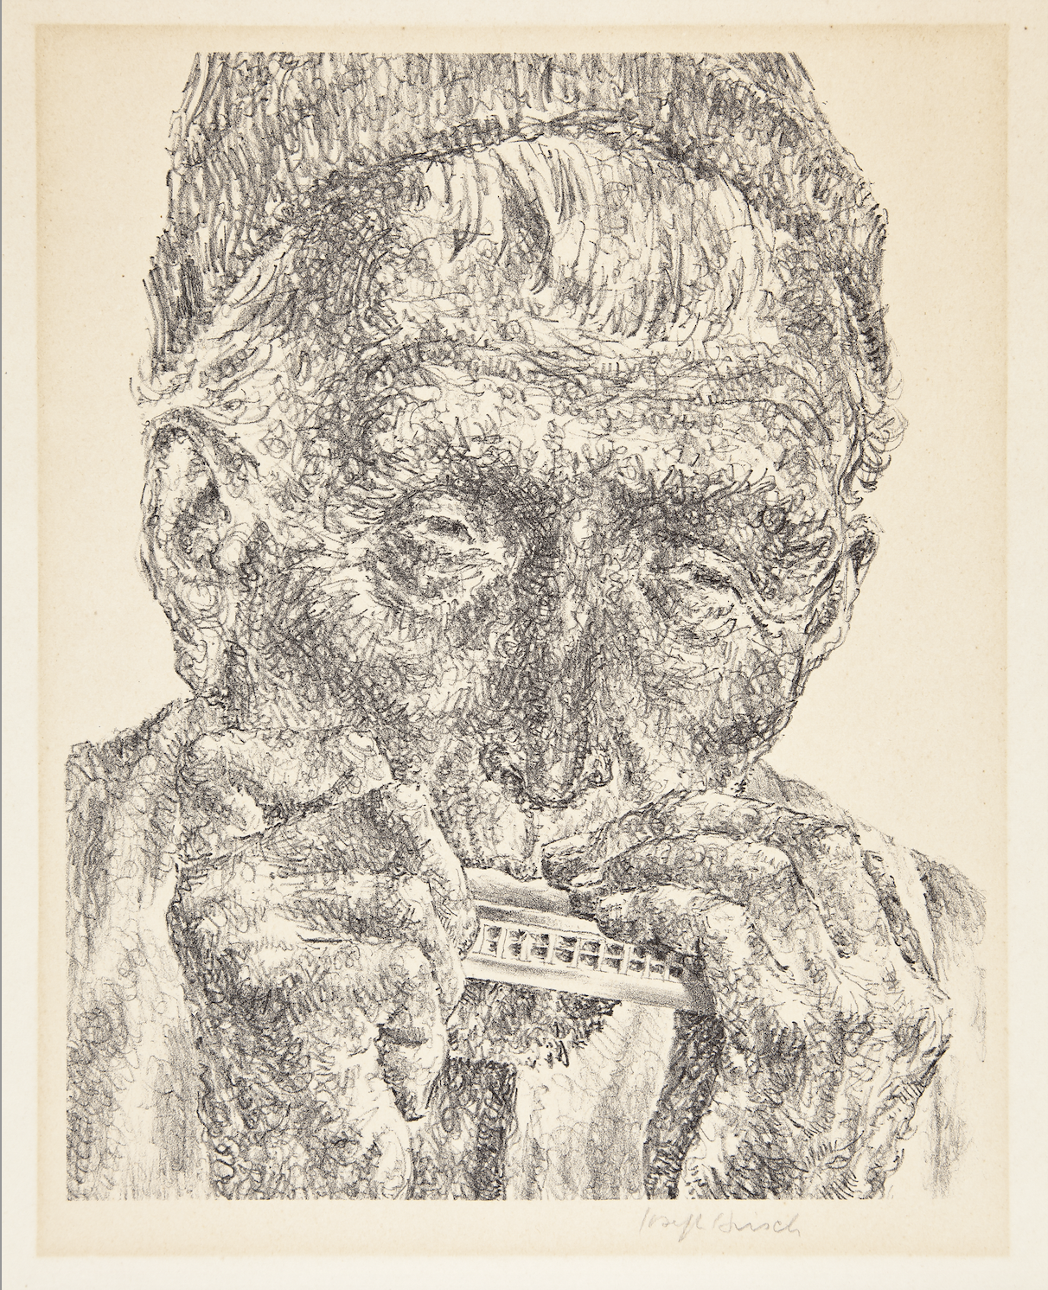
This exhibition, curated by Dickinson College student Sophy Nie ‘25, illuminates the link between visual arts and sound and specifically responds to the concept of Deep Listening coined by experimental composer Pauline Oliveros (American, 1932-2016). For Oliveros, Deep Listening relies on active engagement with one’s environment and fosters creativity in art, music, and movement. Her meditative approach to sound can be used to guide perspectives about each other and the spaces people occupy. To Listen Deeply considers how this interest in sound can be applied to how visual and audiovisual works of art are experienced.
The exhibition features a variety of works, including paintings, prints, photographs, video, and sculptures, that reflect different connections with sound, music, and performance. As Oliveros describes in her book A Year of Deep Listening, viewers must employ their “imaginary ear” and imagine the sound for themselves when seeing visual works. The Trout Gallery invites viewers to both listen deeply and look closely to consider how works of art can be approached through multiple senses.

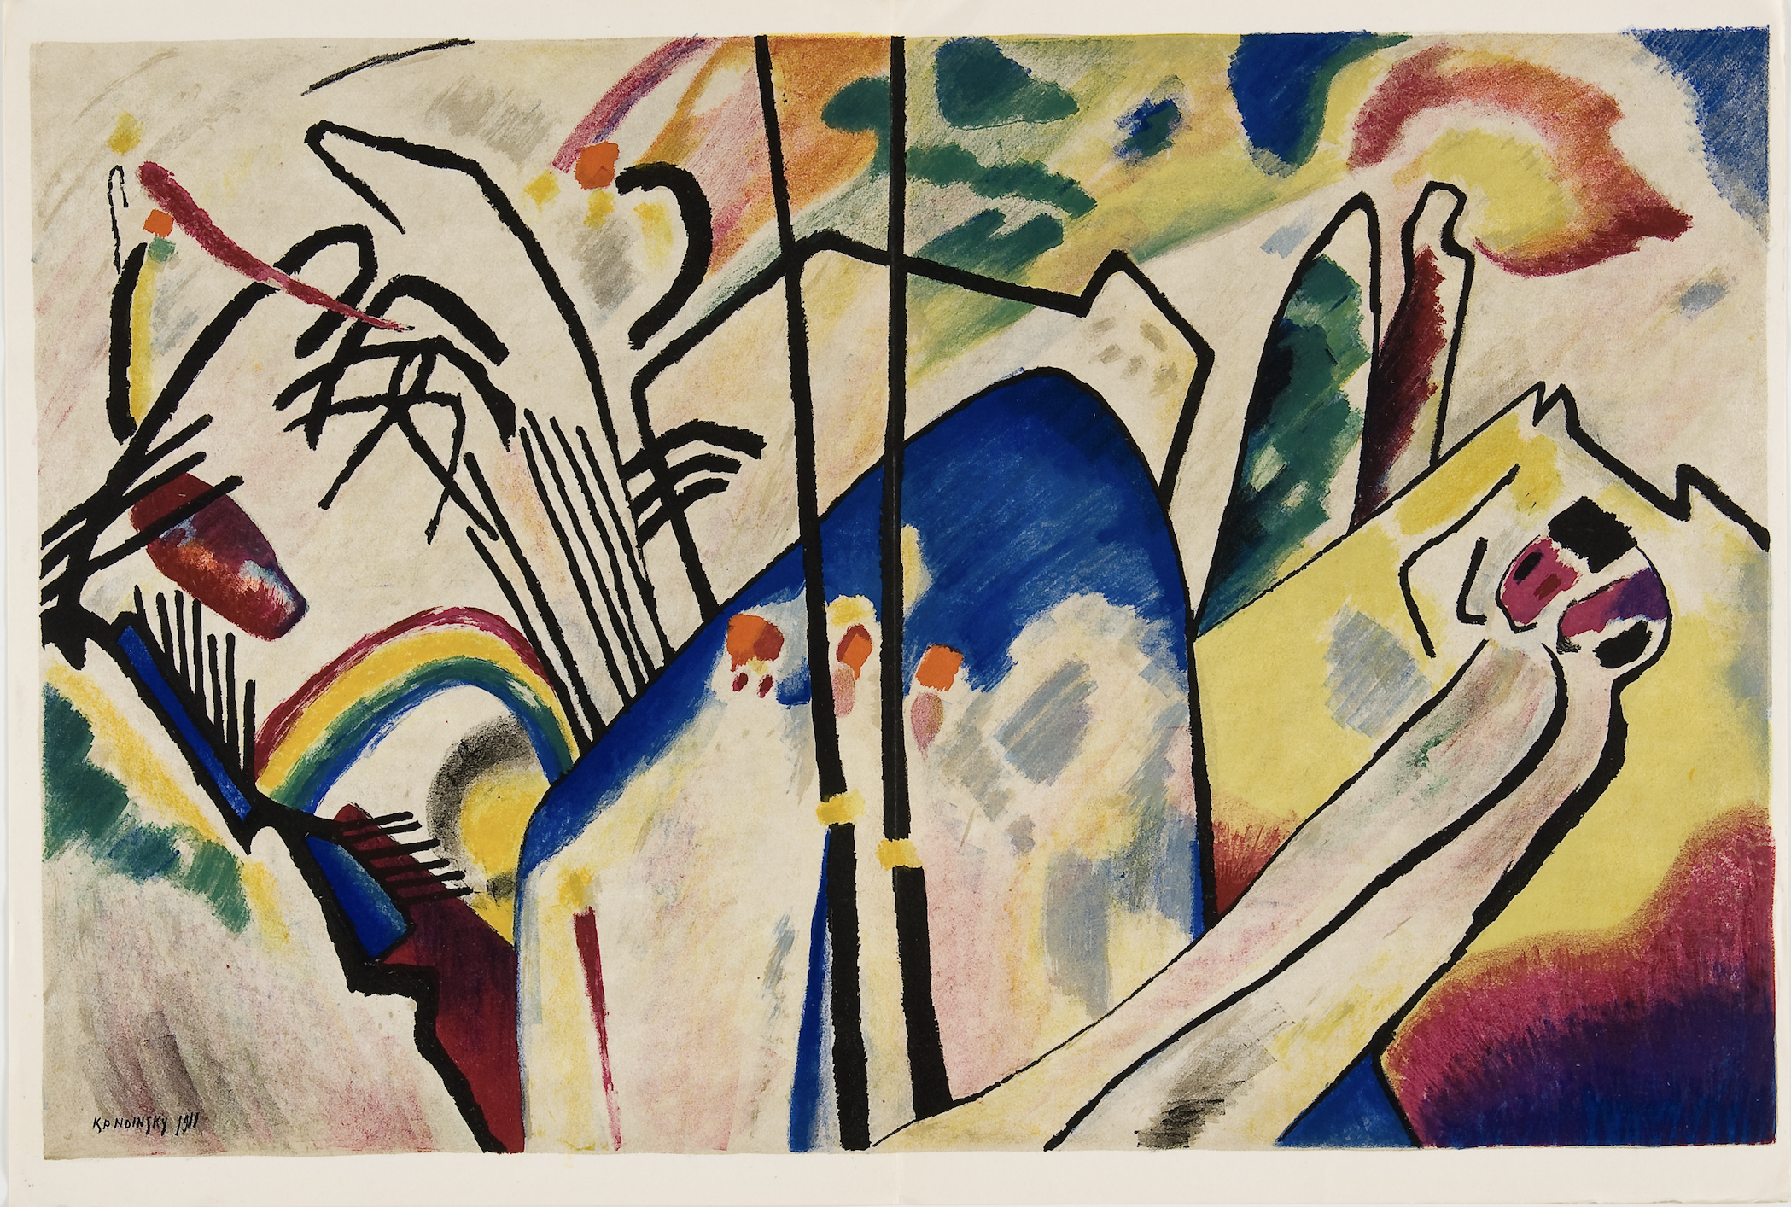
In the spirit of Deep Listening, recent Dickinson College graduate Zuzu Black ‘25 created two musical works that are part of the exhibition. Zuzu, a double-major in Music Theory and Composition and English, took inspiration from Vassily Kandinsky (Russian, 1866-1944) and his experience with synesthesia, a phenomenon in which he heard music when painting and saw colors when listening to music. With the concept of synesthesia in mind, Zuzu composed soundscapes that respond to two works on display: Kandinsky's Composition IV and Utagawa Kunisada’s Listening to the Sounds of Insects on an Autumn Night.
In addition to works by artists Grace Hartigan, Elizabeth Catlett, Toshiko Takaezu, Lida Moser, Manuel Álvarez Bravo, and Tristan Tzara, among others, on display from The Trout Gallery’s permanent collection, viewers will see a video work by artist Lorna Simpson from the Denver Art Museum and a sound-based installation by Louise Lawler on loan from the LeWitt Collection.
This exhibition is accompanied by a full-color exhibition catalogue free of charge to gallery visitors.

Public Events:
All events are free and open to the public

Reception
September 5, 2025, 5-7pm
All are welcome to celebrate the current exhibitions on display with free pizza provided by the Dickinson College farm, live music, and beverages.

Listening In and Out: A Guided Experience
Thursday, October 16, 12-1:15 pm
Join Erin Woods-Burke, Lecturer in Dance at Dickinson College, for an exploration of the Sonic Meditation practices pioneered by composer Pauline Oliveros (1932-2016) in conjunction with the exhibition To Listen Deeply at The Trout Gallery. Inspired by Oliveros’s work with sound, performance, and meditation, Woods-Burke will lead participants through gentle exercises to focus on increased attention to our bodies and environment. This guided experience will be followed by a discussion and complimentary lunch. Space is limited; we kindly ask that guests RSVP at www.troutgallery.org.
To Listen Deeply: Students’ Perspectives on Curating, Creating, and Listening in The Trout Gallery
Tuesday, Nov. 11, 7-8 pm via Zoom: Register here
This Zoom webinar celebrates the curatorial and creative work of two recent Dickinson College alumnae, Sophy Nie ’25 and Zuzu Black ’25, in conjunction with a current exhibition at The Trout Gallery titled To Listen Deeply. Curated by Nie, To Listen Deeply examines how sound is a key component for diverse works of art. Taking inspiration from American experimental composer Pauline Oliveros’s “Deep Listening” philosophy, which encourages a heightened awareness of our sonic environment, this exhibition invites viewers to engage with the works of art on multiple sensory levels, to pay attention to perceived visual and acoustic vibrations – to listen deeply. Reflecting on this intersection of music and art, Black created two original soundscapes in response to two prints on display in the exhibition. Participants will have the opportunity to take a virtual tour through the exhibition and learn more about the multi-disciplinary themes and artistic practices Nie and Black explored.

Dates of Exhibition and Hours:
June 13 – December 14, 2025
Mondays – Saturdays, 10am to 4pm
Free admission.

About The Trout Gallery:
The Trout Gallery is the art museum of Dickinson College. It is always free and open to the public. It is located in the Emil R. Weiss Center for the Arts at 240 West High Street, Carlisle, Pennsylvania, 17013. As a teaching museum, The Trout Gallery promotes curiosity, collaboration, and understanding through active engagement with communities, ideas, and artworks. The Trout Gallery aspires to be a center for cultural and intellectual life on campus and in the community. Through exhibitions, collections, and educational programming, we foster interdisciplinary exploration and offer dynamic experiences that advance the values of creativity, expression, global diversity, and social justice.
Website: www.troutgallery.org
Facebook and Instagram: @troutgallery

Image Captions:
(above): Jospeh Hirsch (American 1910-1981), Music, 1951, Lithograph on paper, 10 x 8 in (25.4 x 20.32 cm). The Trout Gallery, Gift of Diana Rosenberg Slotznick, 2014.11.12.
(below): Vassily Kandinsky (Russian 1866-1944), Composition IV, from Derrière le Miroir, Lithograph on paper, 15 x 11 in., 1955, 1969.1.15.80, Gift of the Doctors Meyer P. and Vivian O. Potamkin.

###

